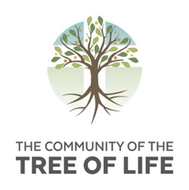

Community of the Tree of Life
Application Form (Part 2)

September 2021 – June 2022

SECTION C

Introduction

In this form we are inviting you to say more about yourself, your faith life and your reasons for applying to join the community.

Please start by telling us your name.

Title Title
First Name First Name
Other/Middle Name(s) Other Names
Last Name Last Name

Preferred Name Preferred Name

Personal Details

Please tell us about your personal skills and interests.
Click here to enter your answer

- Church Involvement

Are you regularly involved in a church community?
Yes No

Name of the church where you worship most regularly
Click here to enter your answer

Denomination or affiliation
Denomination

Briefly describe your own personal experience of church
Click here to enter your answer

Church Influences

What kind of experience do you have of people from other Christian churches or traditions than your own?
Click here to enter your answer

What is the most challenging or most radical thing you have seen done in a church?
Click here to enter your answer

Supporting Statement

Please write freely about yourself. The following are possible areas that you may wish to write about:
- who you are
- your faith journey
- what particularly attracts you to apply for this year at the Community
- what you plan to do after this year, if you are accepted
- what you will do if you are not accepted
Click here to enter your answer

Declaration

Did someone help you to fill out this form? Yes No
If so, who helped you, and in what way?
Click here to enter your answer

I agree to my details being stored electronically for the purpose of this application.
(All such records will be destroyed either upon the unsuccessful completion of this application,
or within 2 years of having completed the programme.)

Name: Name

Submission Date: Date

